CMSD TRANSPORTATION  school bus enrollment  2023-2024  May 30 – july 10, 2023 | - 
  ATTENTION PARENTS & GUARDIANS  To be more efficient with our transportation services, we are requiring parents to OPT-IN for school bus transportation for the 2023-2024 school year.  - This is for all Cleveland residents who are eligible for transportation.  - Families will have the opportunity to OPT-IN for AM transportation, PM transportation, or ROUNDTRIP.  - To register for school bus transportation, point your cell phone or computer camera at the QR Code and complete the form online before the deadline.  - We know circumstances change throughout the year. Parents will always have the opportunity to change their transportation request after July 10 by contacting 216-838-4BUS (4287). | 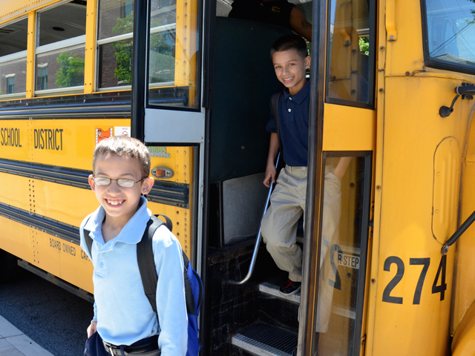  Scan Me    Opt-In Enrollment Period  May 30 – July 10, 2023

